Mekong’s Travel
Preview Mekong River Tour in Vietnam – Day Trip to the Delta
Southern Vietnam is home to the Mekong Delta. A vast network of rivers lined with mangroves and floating villages. If you’re short on time but still like to visit, the Mekong Delta day tour from Ho Chi Minh City (HCMC) is an unforgettable option.
Many tour companies offer a similar itinerary to the Mekong Delta in southern Vietnam. There’s more than just seeing the Mekong Delta on this southern Vietnam your itinerary.
Temples and local treats are also part of this tour. Before reading on, if you’re looking for a quiet, relaxed and time spent away from other tourists, this probably isn’t the tour for you.
There is little time to sit and relax other than the bus and there are many tourists doing the same tour. Many companies also offer an overnight tour of the Mekong Delta, which may help reduce the number of tourists you encounter.
But this review will focus on a day tour to Vietnam’s Mekong Delta. Keep reading for a rundown on what to expect by visiting Vietnam’s Mekong Delta on a day trip from HCMC.
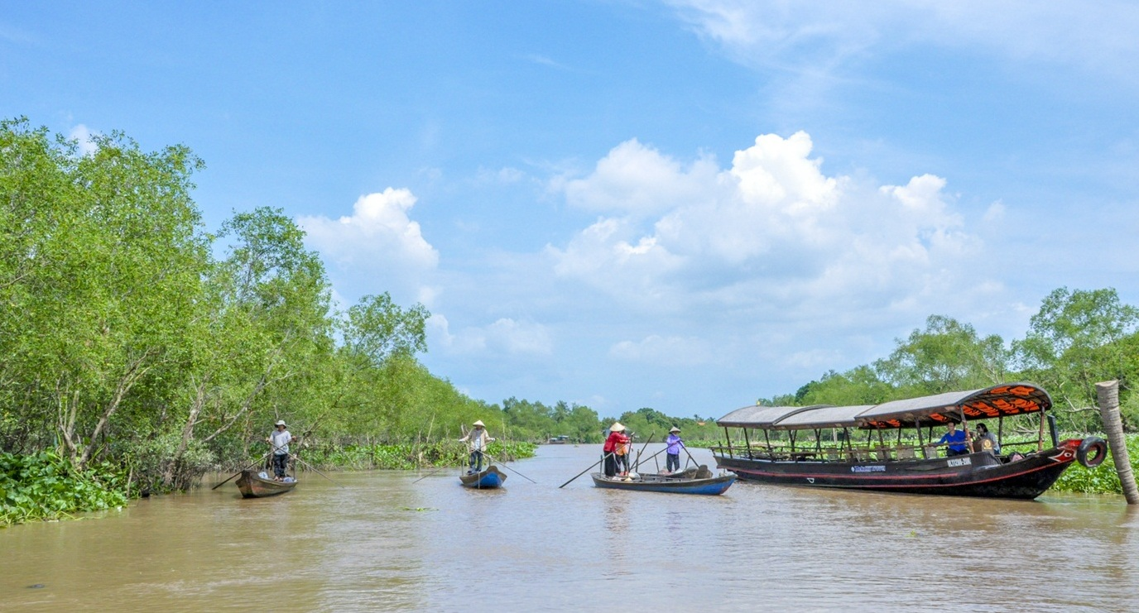
This tour begins on April 20. Get more info from:
Mekong’s Travel
mekongtravel@gmail.com

